Task 4:

In this section, we will provide a comprehensive analysis of Dibs’s sales data, focusing on the visualizations requested by the management team. The visualizations include:

1. **Monthly Sales Trend vs. Monthly Average Sales**
2. **Sales by State**
3. **Sales by City**
4. **Monthly Order Trend vs. Monthly Average Order**
5. **Daily Order Trend vs. Daily Average**
6. **Hourly Order Trend vs. Hourly Average Order**

We will explore each one of these visualizations to uncover insights and trends in Dib’s sales data. The goal is to provide actionable information that can assist the management team in making informed decisions and optimizing Dib’s sales strategies.

1. **Monthly Sales Trend vs. Monthly Average Sales**

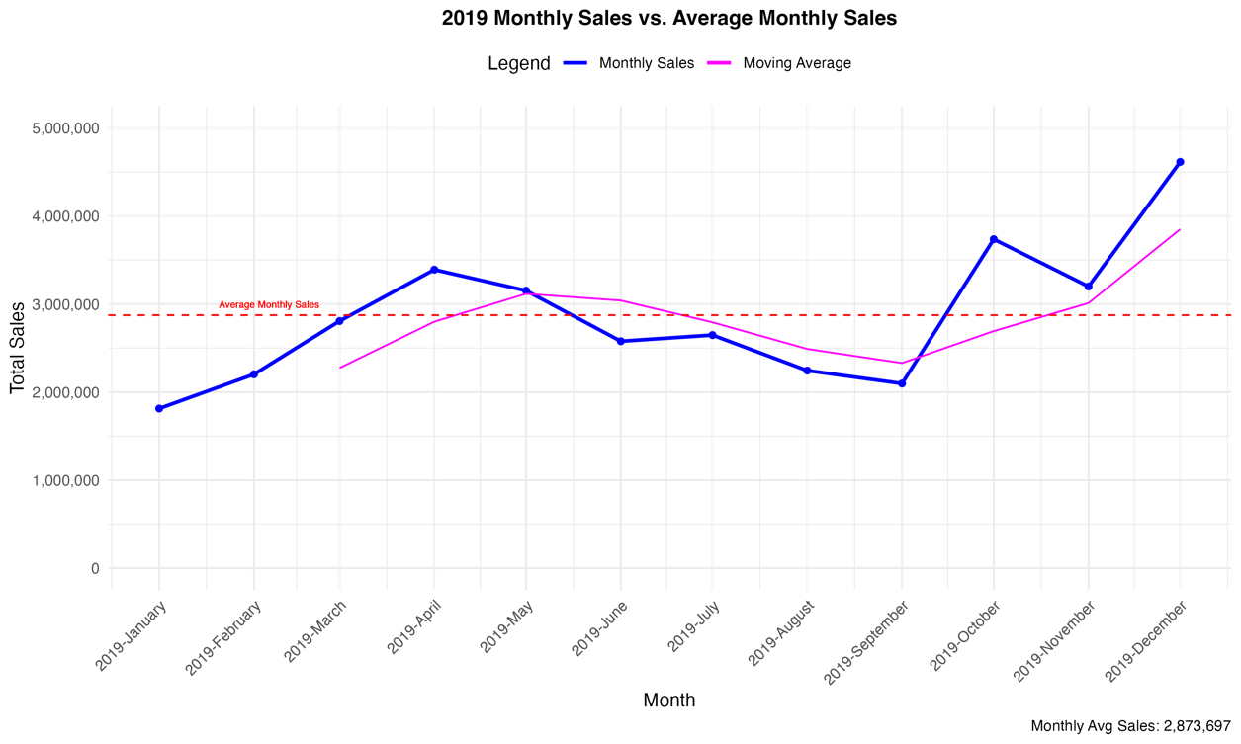

**Observations:**

* December showed the highest sales figures, while sales in January are the lowest.
* Sales exhibited a consistent upward trend during the initial four months, followed by a continuous decline from May to August.
* October witnessed a notable increase, recovering from the low sales figures recorded in September.
* The average monthly sales for the year stood at $2,873,697.
* October's substantial increase, surpassing the average line, stands out as a positive anomaly.
* Sales for the period spanning June to September consistently fell below the average line, whereas the months of April to May and October to December consistently surpassed the average line.

**Insights:**

* The December sales indicates a strong seasonal effect, likely due to year-end holiday season. The dip in sales in January suggests a post-holiday slump.
* Months with increasing or high sales could be attributed to various factors, such as new product launches or marketing initiatives.
* Months with low sales may potentially need corrective actions or adjustments in strategy especially during the mid-year months.

1. **Sales by States**
   1. **Bar Chart and Pie Chart of Total Sales per State**

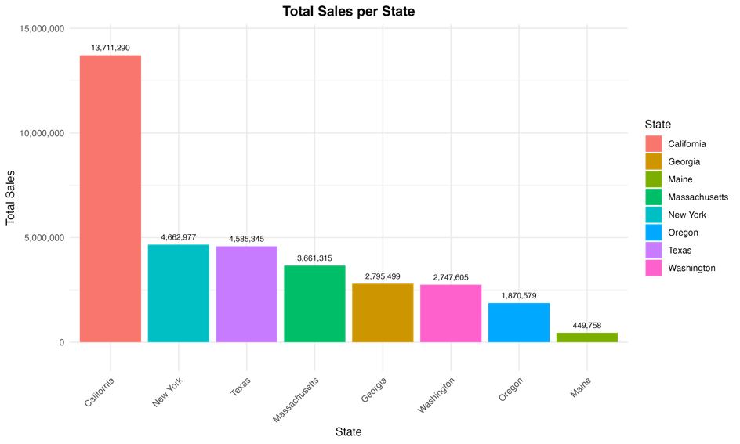

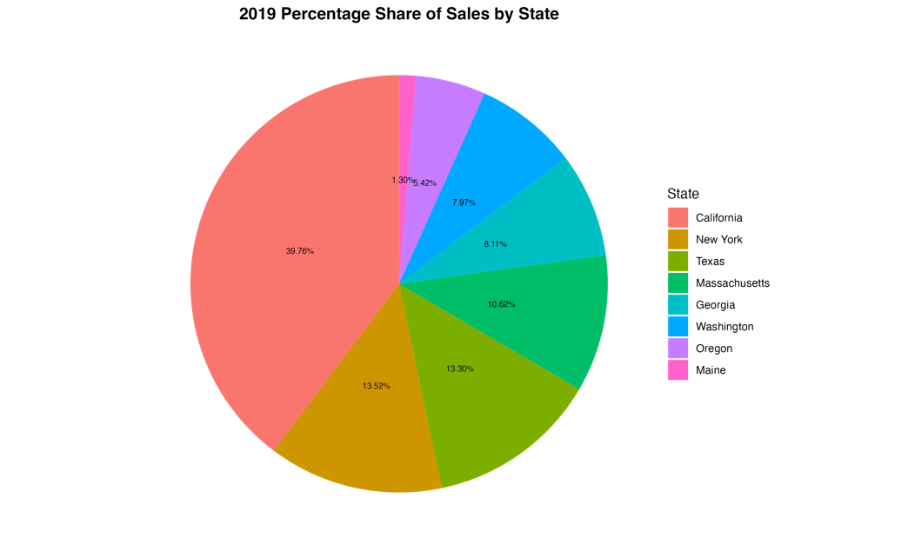

**Observations:**

* California stands out as the top-performing states for gadget sales in 2019, contributing almost 40% to Dib’s total sales.
* New York and Texas exhibit remarkably similar sales performance, with each contributing approximately 13% to the total sales. Maine performs the least among all states contributing only 1.3% to total sales.

**Insights:**

* California is a crucial market for the company, possibly due to its large population and strong consumer demand for gadgets.
* Most online shoppers reside in California.
* Similarity of sales in Texas and New York could indicate that these states have relatively similar consumer preferences or market dynamics
* The low contribution of sales in Maine may be due to factors such as a smaller population or a less pronounced demand for gadgets in the state. It might also present an opportunity for further market development or targeted marketing efforts to increase sales in the said state
  1. **Sales Trend of Monthly Sales by State**

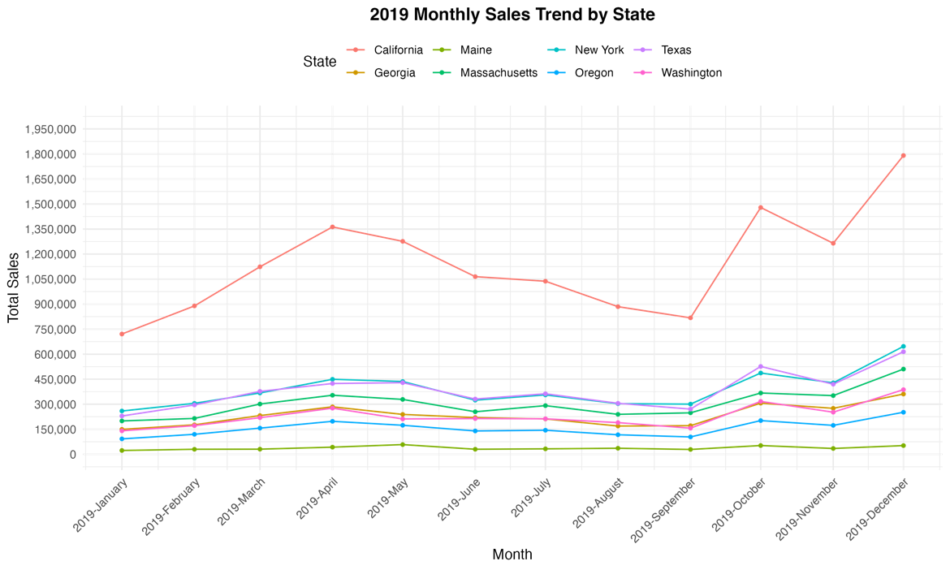

**Observations:**

* The sales trends across all states exhibited a uniform pattern, with consistent increases observed from January through April and again from September to December.

**Insights:**

* Similarity of sales trends across all states may imply that and consumer behaviors and market responses from different states during these periods are relatively uniform, and can be attributed to consistent seasonality effect.

1. **Sales by City**
   1. Bar Graph of Total Sales per City

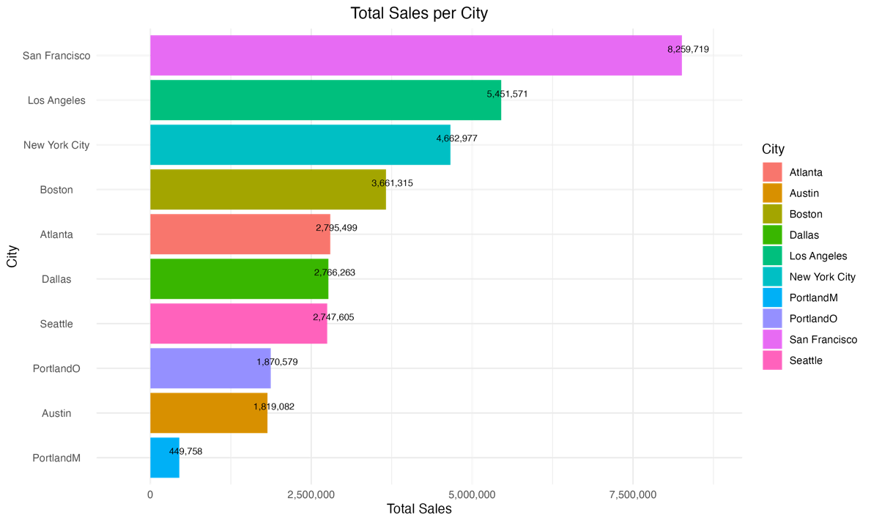

**Observations:**

* San Francisco is the top-performing city in terms of sales in 2019, followed by Los Angeles and New York City.
* Boston also demonstrated strong sales.

**Insights:**

* San Francisco having the highest sales can be due to factors like a strong local economy, a tech-savvy population, or effective marketing efforts in the area.
  1. Sales Trend by City

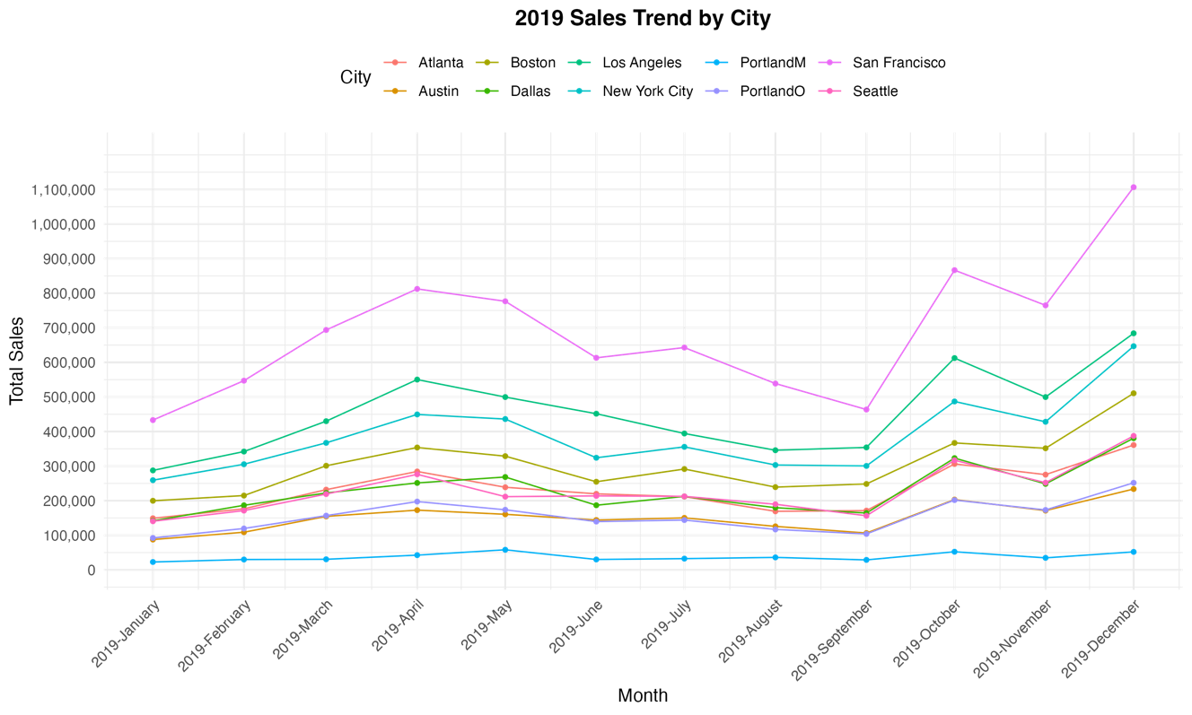

**Observations:**

* There are similarity of patterns across all cities although the following differences in patterns were observed:
  + In May 2019, Dallas was the only city experiencing sales growth, while the others witnessed declines.
  + In July 2019, Los Angeles was still declining, while the remaining cities began to recover from a consistent downturn that had persisted since May.

**Insights:**

* Dallas being the only city with sales growth in May 2019 indicates the possibility of unique factors influencing Dallas's sales during that time. These factors might include localized promotions, Dallas’ local economic conditions, or shifts in consumer behavior that set Dallas apart from the other cities.
* Local factors might also affected the decline in sales of Los Angeles in June 2019.

1. **Monthly Order Trend vs. Monthly Average Order**
   1. Monthly Order Trend vs. Average Monthly Orders

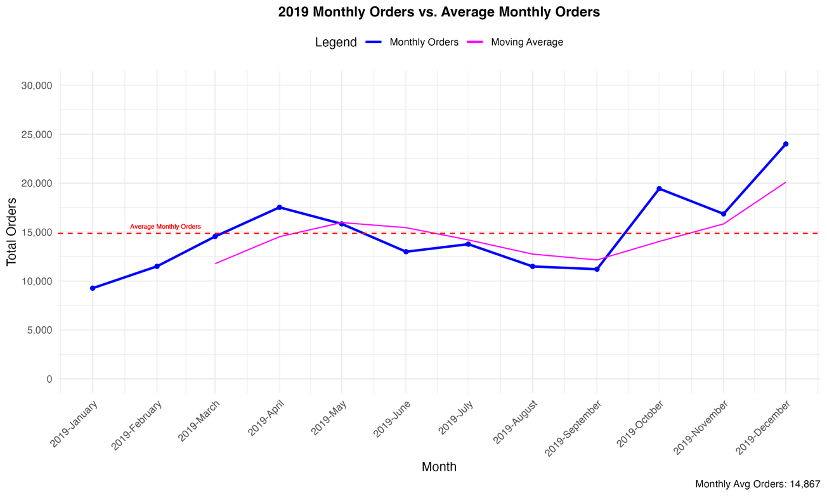

**Observations:**

* Monthly orders also moved in similar patterns with the monthly sales trend.
* Sales in October nearly doubled compared to September, rising from approximately 10,000 to nearly 20,000.
* The moving average line illustrates a sales pattern characterized by an initial increase, followed by a mid-year dip, and a subsequent resurgence during the 'ber-months.

**Insights:**

* Dib’s should anticipate and plan for these seasonal fluctuations in orders to optimize strategies, inventory management, and marketing efforts accordingly.

1. **Daily Order Trend vs. Daily Average**
   1. **Daily Order Trend**

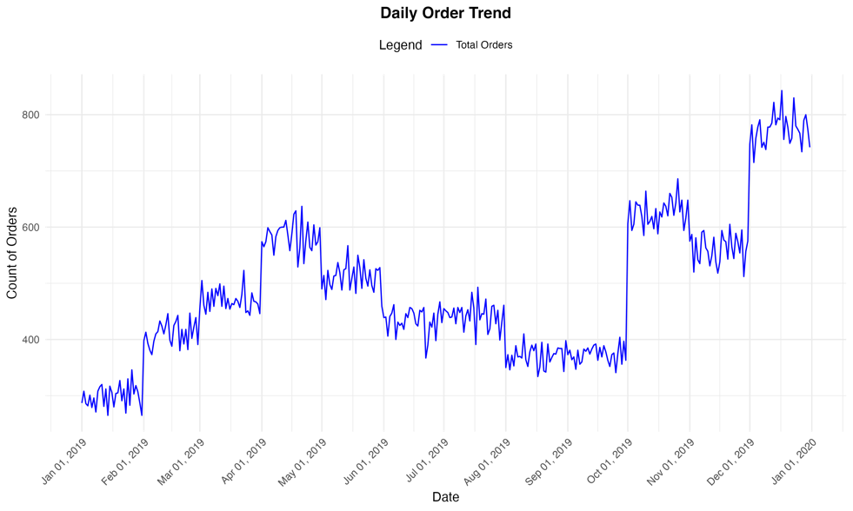

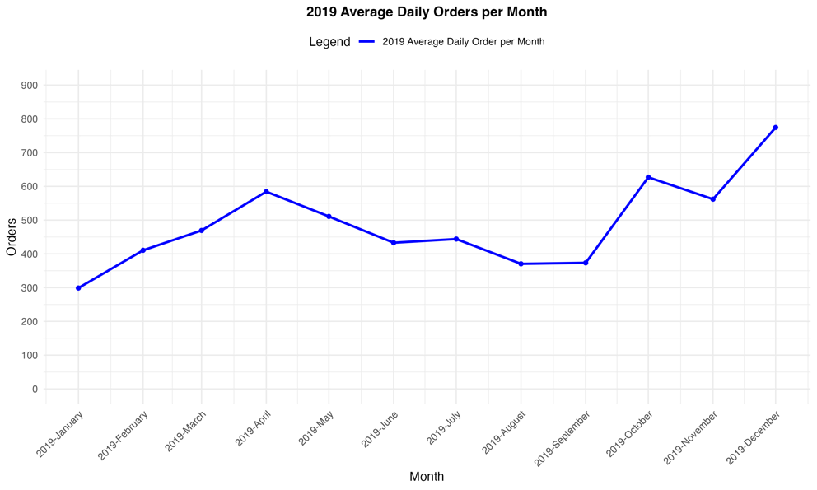

**Observations:**

* Changes in order count usually start at the beginning of the months.
* A non-fluctuating pattern of orders can be observed from June until end of July and from August until end of September 2019.
* Daily Orders are fluctuating in each month.
* January appears to be the month with the lowest order volume in 2019.

**Insights:**

* The daily variations in order counts suggest that customer demand and purchasing patterns are not consistent. This may include differences in order volumes between weekdays and weekends, the influence of special events or promotions that temporarily boost orders, and various customer-specific factors such as pay cycles or even the weather.

1. **Order Count By Day of Week**

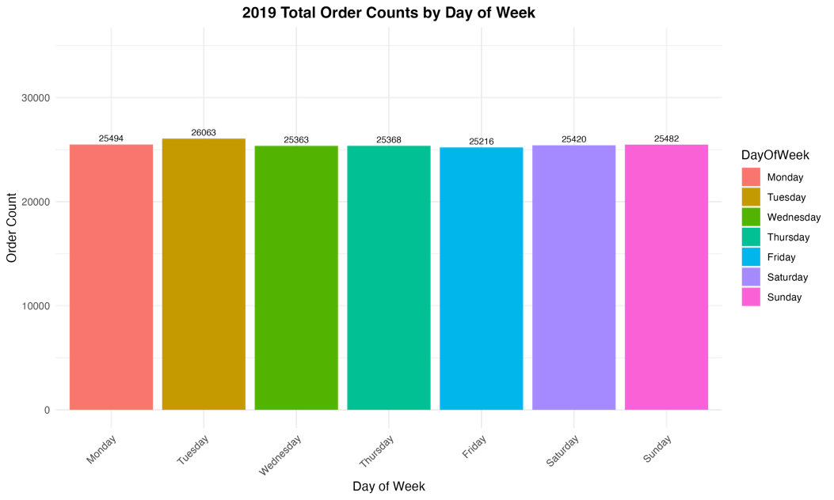

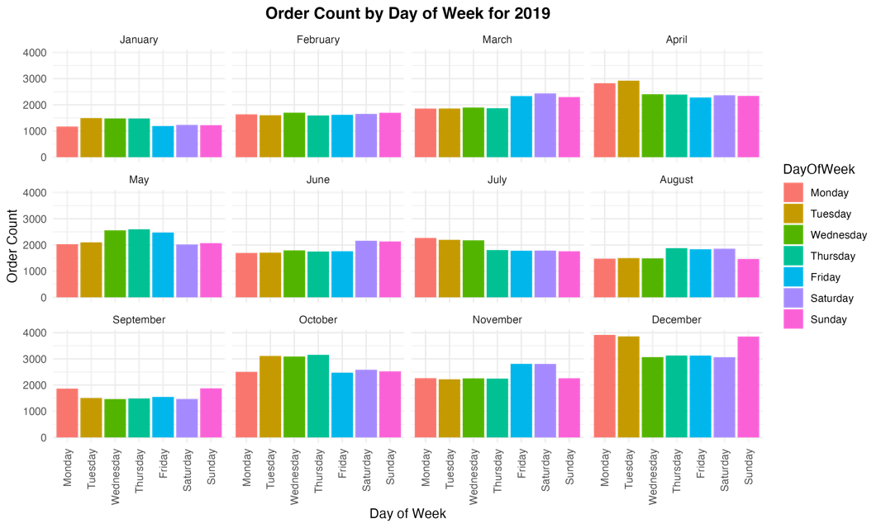

**Observations:**

* Each month displays a distinct pattern in order volume when analyzed by the day of the week.
* The overall trend suggests that the day of the week does not significantly affect the ordering habits of customers, despite noticeable fluctuations on specific days within each month that warrant closer examination.

**Insights:**

* Weekdays do not consistently correspond with higher sales figures.

1. 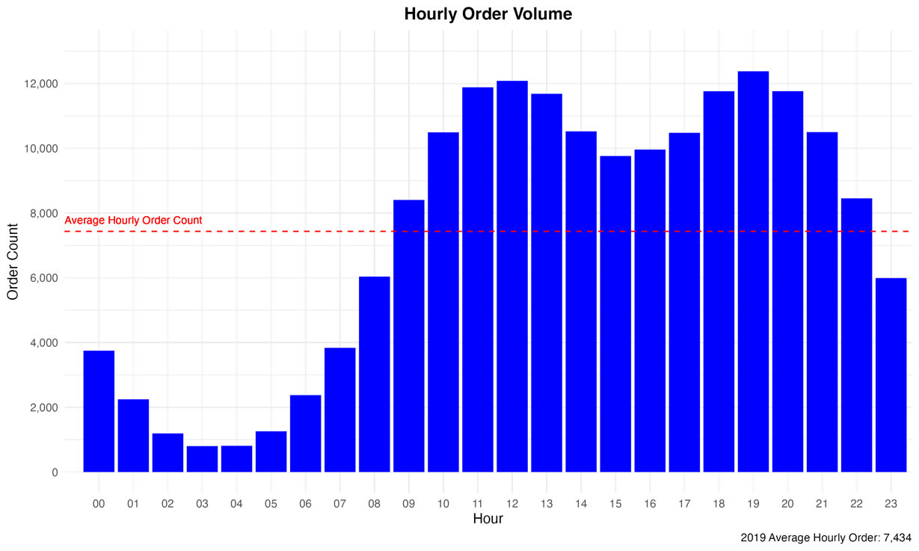**Hourly order trend vs hourly average order**

**Observations:**

* + There is a pronounced increase in order volumes around midday and the onset of the evening.
  + Order activity is noticeably lower in the early morning hours.

**Insights:**

* Online shopping tends to peak during lunch hours, continues throughout the afternoon, and remains high until 9 PM. This suggests that these times may coincide with periods when consumers generally have breaks or are free from other commitments, indicating that these hours are likely when they have discretionary time for online purchases.
* **RECO:**  
  Months with low sales may potentially need corrective actions or adjustments in strategy especially during the mid-year months.
* Maine has several opportunities to grow, and targeted marketing efforts in this state may further boost sales.
* Company should take a closer look at Dallas on May 2019 why it was the only city increasing in sales. It’s good to identify Local factors affecting the growth and check if it can be applied to other cities as well.
* It’s good to study the decline in sales of Los Angeles on July 2019, Los Angeles so that Dib’s can protect its future performance on this particular month. It’s good to identify what’s wrong and learn from this.
* Marketing efforts can be applied during mid-months where sales typically start to decline.
* It is also great to offer promotions during January to push sales upward.
* Company should forecast and anticipate order surge during months of October and December where demand is high.
* It might be good to create promotions or product launches during pay days as this is the time where consumers have the power to spend.
* It’s good to create awareness campaign during April or during holidays as traffic is high during these months
* Marketing can also create sales promotions such as midnight sales or early bird promos to increase traffic during slack hours.

In conclusion, our thorough analysis of Dibs' 2019 customer purchase history through data visualization, statistical techniques, and machine learning models has yielded a multitude of valuable insights into customer behaviors and trends. By leveraging this data, Dibs is now equipped with a strategic blueprint tailored to enhance its sales and marketing efforts. Our recommendations, grounded in data-driven evidence, are poised to bolster customer loyalty and catalyze sales growth.

In closing, our team is confident that the actionable insights provided will serve as the catalyst for Dibs to not only navigate the current market challenges but to thrive and secure a position as a leading innovator in the competitive online retail space.